/* Homework, 14 points */ /* Given the significance level = 0.05 */

/* (1) Please write down the GLM model. */

log(y) = log(2) + β0 + β1 * bline + β2 * trt + β3 * age

→ log(y) = log(2) - 0.1368 + 0.0228 * bline - 0.1472 * trt + 0.0227 * age

y：每兩周發生癲癇的次數

bline：前 8 周發生癲癇的次數

trt：治療組別

/* GLM model */

**proc** **genmod** data=new;

class id;

model y=bline trt age / d=poisson offset=ltime;

**run**;

/* (2) Please write down the assumed probability mass function (p.m.f. in GLM) for the response variable. */

Y ~ Poisson(λ)

$$f\left(y\right)=\frac{e^{-λ}λ^{y}}{y!}$$

/* (3) According to the deviance statistic, is the GLM model fitted well? */

Deviance = [ logLik(β̂saturated) − logLik(β̂current) ]

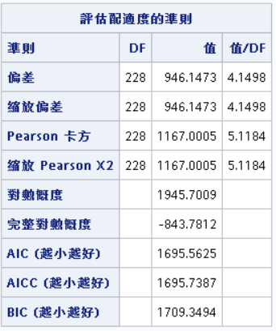

在此 Deviance=946.1473

H0: current model 和 saturated model 無異

H1: current model和 saturated model 有異

藉由 R 軟體計算

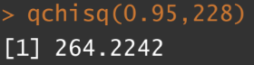

顯著水準 0.05 下，自由度為 228 的卡方分布臨界值為χ20.95,228 = 264.2242

在此 Deviance=946.1473>264.2242，Reject H0，the model is not fitted well。

/* (4) According to the GLM model, can progabide reduce seizure rate? */

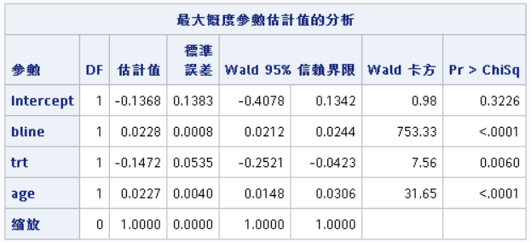

GLM model可以發現 progabide(治療組)有 reduce seizure rate，p-value = 0.006 達顯著，且係數為-0.1472，表示有服藥者平均一周癲癇發作次數是未服藥者的exp(−0.1472) = 0.86倍。

/* (5) Please write down the quasi-likelihood (GEE) for the response variable. */

Y ~ Poisson($μ$)

$$f\left(y\right)=\frac{e^{-μ}μ^{y}}{y!}=e^{ylogμ-μ-log(y!)}$$

/* (6) According to the GEE model, can progabide reduce seizure rate? */

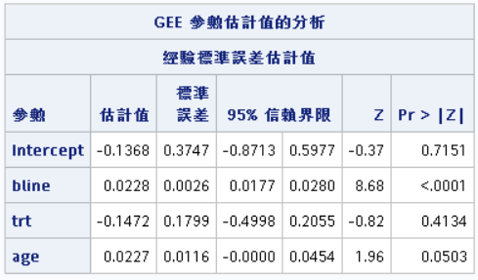

雖然 trt 的係數一樣為-0.1472，但p-value=0.4134未達顯著，故沒有證據說 progabide can reduce seizure rate。

/* GEE model */

**proc** **genmod** data=new;

class id;

model y=bline trt age / dist=poisson offset=ltime;

repeated subject=id / type=exch corrw covb;

**run**;

/* (7) Which model (GLM or GEE) will you choose? Why? */

GEE model，已由第(3)題得知GLM model配適的不佳，考量到每筆資料不同 id 間每次visit得到的癲癇次數會有相關性，屬重複測量資料，故使用 GEE 方法可行性較高。